System Requirements Statement (SRS) –

E-College Portal

1. Introduction 3

2. Functional Requirements 4

2.1 Student Module 5

2.2 Staff Module 11

2.3 admin Module 13

2.4 Use Case Diagram.............................................................................................................................15

THIS DOCUMENT CONTAINS 17 NUMBERED PAGES

# Introduction

This document explains the system requirements and scope for developing E-College Portal.

E-College Portal could divide the three main parts, Student part, Staff part and the Admin part.

# Functional Requirements

The **E-College Portal** includes three modules — **Student**, **Staff**, and **Admin** — each with its own set of features listed below.

|  |  |  |
| --- | --- | --- |
| **No** | **BRS requirement ID** | **Description** |
| **2.1** | **Student Module** | |
| **2.1.1** | **F1** | **Account Creation Process** |
| **2.1.2** | **F2** | **Login Process** |
| **2.1.3** | **F3** | **Forgot Password Process** |
| **2.1.4** | **F4** | **Change Password Process** |
| **2.1.5** | **F5** | **Update Profile Information** |
| **2.1.6** | **F6** | **View Personalized Dashboard** |
| **2.1.7** | **F7** | **Browse for Skill Development Courses** |
| **2.1.8** | **F8** | **Register for Skill Development Courses** |
| **2.1.9** | **F9** | **Access Enrolled Courses & Download Course Materials** |
| **2.1.10** | **F10** | **Register for upcoming events** |
| **2.1.11** | **F11** | **Apply for Internships & Placements** |
| **2.1.12** | **F12** | **Track Internship & Job Application Status** |
| **2.1.13** | **F13** | **Provide Feedback on Courses, Faculty, Events** |
| **2.2** | **Staff Module** | |
| **2.2.1** | **F14** | **Login Process** |
| **2.2.2** | **F15** | **Forgot Password Process** |
| **2.2.3** | **F16** | **Change Password Process** |
| **2.2.4** | **F17** | **Update Profile Information** |
| **2.2.5** | **F18** | **View Personalized Dashboard** |
| **2.2.6** | **F19** | **Upload & Manage Course Materials** |
| **2.2.7** | **F20** | **Post Announcements** |
| **2.3 Admin Module** | | |
| **2.3.1** | **F21** | **Login Process** |
| **2.3.2** | **F22** | **Forgot Password Process** |
| **2.3.3** | **F23** | **Change Password Process** |
| **2.3.4** | **F24** | **Update Profile Information** |
| **2.3.5** | **F25** | **Manage User Accounts** |
| **2.3.6** | **F26** | **Manage Course Catalog** |
| **2.3.7** | **F27** | **Review Student Feedback** |

## Student Module

* Student is the primary user of the system who accesses academic and campus-related features.
* They can view their dashboard, access course materials, register for skill development courses and events, and apply for internships and placements.
* Students can also track their application status, give feedback.

### Account Creation Process

* **The E-College Portal requires students to create an account before accessing any services.** Therefore, the system should provide a function that allows students to register by creating a new account.
* When a student creates a new account, the system collects three main types of information:

1. Login information
2. Contact Details
3. Security Question Information

* The Login information

The Login information consists of some items described as below.

1. User ID
2. Password
3. PRN
4. First Name
5. Last Name
6. E-mail address
   * All items are compulsory demanded.
   * UserID

* The UserID should be unique. If the UserID correspond with not case-sensitive to other which is previously registered, the UserID should not be registered as an account.
* Registration should be prevented if the User ID already exists.
  + Password
* The Password has constrains which makes the Password consists of more than or equal 8 and less than or equal 16 characteristics including characters described as below.

1. Numeric figure (at least one)
2. Capital alphabet (A-Z)(at least one)
3. Small alphabet (a-z)(at least one)
4. Special character (#, $, %, &, etc.) (at least one)

* The Password is masked by dummy characters. The re-entering Password is demanded.
* The Password must be encrypted in e-Farming System.
* Contact Details
* The Contact Detail consists of some items described as below.

1. Permanent Address
2. Contact Phone No
   * All items are compulsory demanded.
   * Permanent Address

* Permanent Address should be filled.
* But only the state should be selected from options.

### Login Process

* E-College Portal always compels user authentication before using itself except when a new account is successfully created.
* The user authentication demands UserID and Password. The UserID and the Password should be checked in three ways.
  1. First, the UserID and the Password should exist and be correct.
     + If the UserID and the Password are not equal to what the user has registered, the user authentication cannot be provided.
  2. Second, the User Type linked to the UserID should be one of “Student”, “Staff”, or “Admin”.
     + When the User Type is “Student”, then user can be placed on “Student Dashboard”.
     + When the User Type is “Staff”, then user can be placed on “Staff Dashboard”.
     + When the User Type is “Admin”, then user can be placed on “Admin Dashboard”.
  3. Finally, UserID should be available.
     + The Administrator can decide whether the UserID is available or suspended – Refer to the SRS of the Admin part.
     + If the account is suspended or terminated, user authentication is not provided for the system user.
* The user account should remain active for so long as the duration decided by Admin.
* Only when the three checks are successfully completed, the user can be placed on the respected dashboard page according to User Type.
* The dashboards provide the following items described as below.

Student Dashboard provides:

1. A trigger to Logout
2. A trigger to Update Profile (F5)
3. A trigger to Change Password (F4)
4. A trigger to Browse Skill Development Courses (F7)
5. A trigger to Register for Skill Development Courses (F8)
6. A trigger to Access Enrolled Courses & Download Course Materials (F9)
7. A trigger to Register for Upcoming Events (F10)
8. A trigger to Apply for Internships & Placements (F11)
9. A trigger to Track Internship & Job Application Status (F12)
10. A trigger to Provide Feedback on Courses, Faculty, Events (F13)

### Forgot Password Process

* When system user lost their Password, the recovery method should be provided by e-college portal.

The recovery method is described as below.

* + First, system user enters their UserID for e-college portal.
  + Next, E-College Portal demands the Answer which has been registered since when the Account was created.
  + Only when the Answer is correct, farmer get the new password by E-mail which also has been registered since when the Account was created.
  + The new password is automatically generated by e-college portal.
* Of course, the new password should consist of more than or equal 8 and less than or equal 16 characteristics including at least a numeric figure, a capital alphabet, a small alphabet, and a special character.
* As a consequence, The Student could get the user authentication using the new password.
  + Then, the student had better change the new password manually.

### Change Password Process

* When Student wants to change their Password, the measure should be provided by e-college portal.
* Therefore, e-college Portal should provide the function which is available after getting the farmer authentication.
* The function demands the current password and the new password.
  + Of course, the new password should consist of more than or equal 8 and less than or equal 16 characteristics including at least a numeric figure, a capital alphabet, a small alphabet, and a special character.
  + The current password and the new password are masked by using dummy characters.
  + The new password is demanded to enter twice to avoid a typing error.
* Only when the current password is correct, farmer could change their Password.
* When the current password is changed into new password, E-College Portal compels user authentication again.

### Update Account Process

* E-College Portal should provide the function which makes the account updated for farmer.
* The information student could update is described below.

1. Login information
2. User information

* The Login information

The updatable items as described below.

1. First Name
2. Last Name
3. E-mail address
   * All items are compulsory demanded, but updating is optional.

* The User information

The updatable items as described below.

1. User Name
2. User Phone No
3. E-mail address
4. Permanent address
   * All items are compulsory demanded, but updating is optional.

### 2.1.6 View Personalized Dashboard

* The system shall provide each student with a personalized dashboard after login.
* The dashboard will display key academic and campus-related information such as:
* Current enrolled courses and their status.
* Upcoming events, and announcements.

### 2.1.6 Browse for Skill Development Courses

* Students shall be able to browse the list of available skill development courses.

### 2.1.8 Register for Skill Development Courses

* The system shall allow students to register for selected skill development courses.  
  Registration will include:
* Selecting a course from the available list.

### 2.1.9 Access Enrolled Courses & Download Course Materials

* Students shall be able to view all their enrolled courses and access course-related resources.
* Course pages will provide downloadable materials (PDFs, presentations, videos).
* Materials will be accessible anytime during the course duration.
* The system will ensure only enrolled students have access to course materials.

**2.1.10 Register for Upcoming Events**

* The system shall allow students to view and register for upcoming campus events such as workshops, seminars, cultural activities, and competitions.
* Event details will include date, time, venue, description.

**2.1.11 Apply for Internships & Placements**

* Students shall be able to apply for available internship and placement opportunities posted by the placement cell or partner companies.
* Listings will display company details, job description, eligibility, and application deadline.
* Students can submit applications and upload required documents (e.g., resume).

**2.1.12 Track Internship & Job Application Status**

* The system shall allow students to track the status of their internship and job applications in real-time.  
  Statuses may include:
* Application Submitted
* Under Review
* Shortlisted
* Selected
* Rejected

**2.1.13 Provide Feedback on Courses, Faculty, Events**

Students shall be able to submit feedback on completed courses, faculty performance, and campus events.

* Feedback forms will include both rating scales and open-text comments.
* The system will ensure anonymity of student responses when required.
* Feedback data will be used for quality improvement purposes.

#### 2.2Staff Module

**2.2.1 Login Process**

* The system shall require staff members to authenticate themselves before accessing their accounts.
* Staff must enter a valid User ID and password.
* Credentials will be validated against the system’s stored records.
* Upon successful authentication, the staff member will be redirected to their personalized dashboard.
* In case of multiple failed login attempts, the account will be temporarily locked for security.

**2.2.2 Forgot Password Process**

* The system shall provide a secure process for staff members to recover their password in case it is forgotten.
* Staff members will enter their registered User ID.
* The system will verify their identity using a security question or registered email.
* Upon successful verification, a system-generated password will be sent to the registered email.
* Staff will be prompted to change the password upon their next login.

**2.2.3 Change Password Process**

* The system shall allow staff to change their account password after authentication.
* Staff must enter the current password and the new password twice for confirmation.
* The new password must meet security requirements (8–16 characters, at least one uppercase letter, one lowercase letter, one number, and one special character).
* If the current password is correct, the change will be applied and a confirmation message displayed.

**2.2.4 Update Profile Information**

* The system shall allow staff to update their personal and contact information.
* Editable details include first name, last name, email address, phone number, and address.
* Updates will be validated before saving.
* A confirmation message will be displayed after successful updates.

**2.2.5 View Personalized Dashboard**

* The system shall provide a personalized dashboard to each staff member upon login.
* The dashboard will display assigned courses, uploaded materials, upcoming teaching schedules, and recent announcements.
* It will also show notifications from the admin or other staff members.
* Quick access links to frequently used tools (course management, announcements, profile settings) will be available.

**2.2.6 Upload & Manage Course Materials**

* The system shall allow staff to upload, update, and delete course materials for students.
* Supported formats may include PDF, DOCX, PPT, and video files.
* Each upload will be linked to a specific course.
* Staff can update or replace materials as needed.
* Access to the materials will be restricted to enrolled students.

**2.2.7 Post Announcements**

* **The system shall allow staff members to post announcements for students.**
* **Announcements can include academic updates, schedule changes, event information, and reminders.**
* **They will be visible on the student dashboard and announcement board.**
* **Staff can set an expiration date for announcements.**
* **Announcements can be edited or removed if needed.**

## 2.3 Admin Module

#### 2.2.1 Login Process

#### The system shall require administrators to log in before accessing the Admin Panel.

#### Admins must provide a valid User ID and password.

#### The system will validate credentials against stored admin records.

#### Upon successful authentication, the admin will be redirected to the Admin Dashboard.

#### 2.3.2 Forgot Password Process

#### The system shall provide a secure process for password recovery.

#### Admins will enter their registered User ID.

#### The system will verify identity through the registered email address.

#### Upon successful verification, a system-generated password will be sent to the registered email.

#### The admin will be prompted to change the password after login.

#### 2.3.3 Change Password Process

#### The current password must be entered before creating a new one.

#### The new password must be entered twice for confirmation.

#### The password must meet security requirements (8–16 characters, including uppercase, lowercase, numeric, and special characters).

#### The change will take effect immediately upon successful validation.

#### 2.3.4 Update Profile Information

#### Editable fields include first name, last name, email address, contact number, and address.

#### Changes will be saved after validation.

#### The system will display a confirmation message after a successful update.

#### 2.3.5 Manage User Accounts

#### The system shall allow administrators to manage student and staff accounts.

#### Admins can enable, disable, or delete accounts.

#### Admins can reset passwords for any account.

#### The system shall maintain an activity log of all admin actions on user accounts.

#### 2.3.6 Manage Course Catalog

#### The system shall allow administrators to manage the institution’s course catalog.

#### Admins can add, edit, or remove courses from the catalog.

#### Admins can assign courses to staff members.

#### The system will validate course data before saving changes.

#### 2.3.7 Review Student Feedback

#### The system shall allow administrators to review feedback submitted by students on courses, faculty, and events.

#### Feedback can be viewed in both summarized and detailed formats.

#### Admins can generate reports based on feedback for quality improvement.

#### The system will store all feedback records for future reference.

#### 2.5 Use Case Diagram

**Admin:**

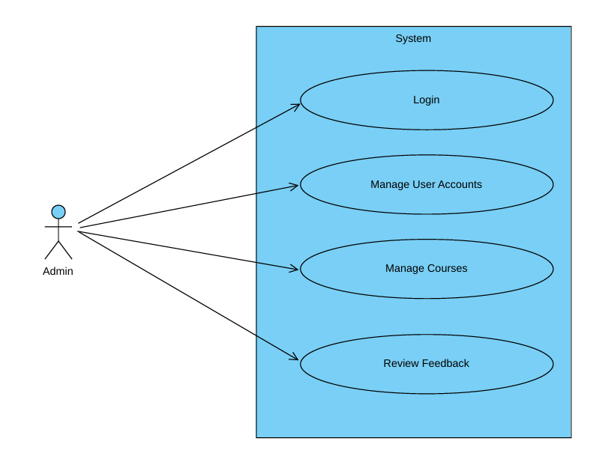

*Fig. Use case diagram for admin*

1. In Admin use case diagram Admin is the Actor.
2. Admin can handle following use cases:
3. Login
4. Manage User Accounts
5. Manage Courses
6. Review Feedback

**Student:**

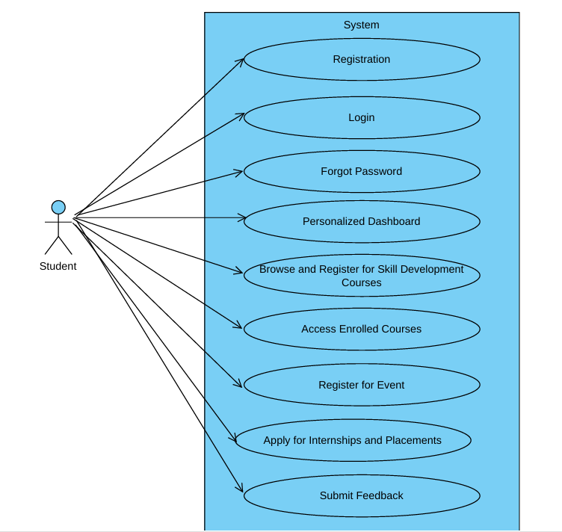

*Fig. Use case diagram for Student*

1. In Student use case diagram Student is the Actor.
2. Student can handle following use cases:
3. Register
4. Login
5. Personalized Dashboard
6. Browse for Skill Development Courses
7. Register for Skill Development Courses
8. Access Enrolled Courses
9. Register for an Event
10. Apply for Internships and Placements
11. Submit Feedback

**Staff:**

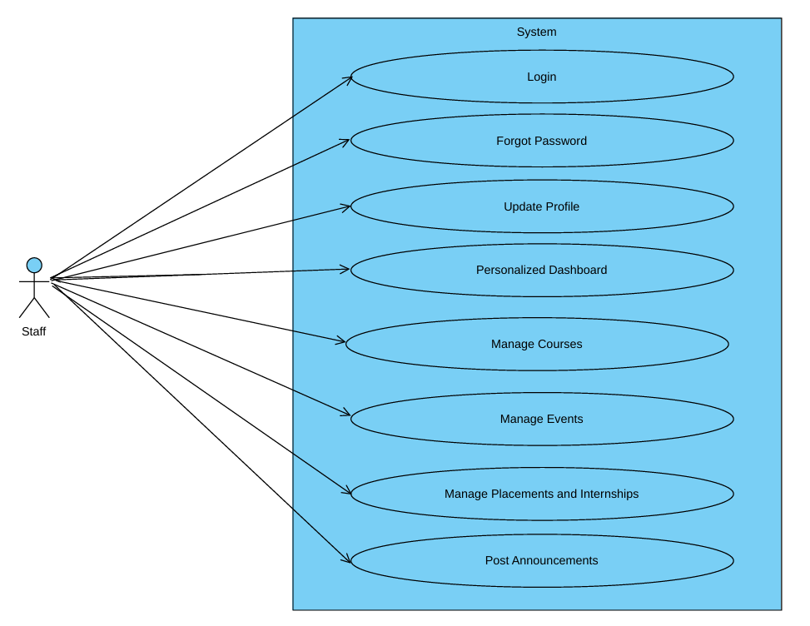

*Fig. Use case diagram for Staff*

1. In Staff use case diagram Staff is the Actor**.**
2. Staff can handle following use cases:
3. Login
4. Update Profile
5. Personalized Dashboard
6. Manage Courses
7. Manage Events
8. Manage Placements and Internships
9. Post Announcements